

HB Library

Group Members

Bhaskar Sharma-300918010

Harmeet Singh Hundal-300973335

Contents

Description:

HB Library is a platform that acts as a home for all your books. Its an online catalog where you can access and search for multiple books from all the majors genres, languages and authors; and get your desired book in a couple of days right on your door step within a few clicks. In addition to that, you can also create your own virtual collection of books, where you can keep track of your progress as well as share your views on different books once you are done reading them. The online catalog also keeps a memory of your preferences and choices and provides you with a periodically reviewed set of books to enhance your reading process. HB Library is also place where you can interact with people around the world who share the same reading interests as you. In addition to all of this, if by chance, you don't find some particular books in the search catalog for HB Library, you can always suggest/order for those books with their names and other required information; and our team would get back to you with the book just the way you want it.

Version History:

* 1. Created the project web forms
     1. Added web forms to the project
     2. Added 4 Pages
     3. Created Database
  2. User registration and login
     1. Allows user to login or register
     2. After login redirects to page with book details
  3. Able to add and manipulate data
  4. Added book details and list
  5. Added tracking page
  6. Added About us page
  7. Directs to tracking page only after the user has logged in.

GitHub - <https://github.com/Bhaskar8sharma/Comp229-TeamAssign>

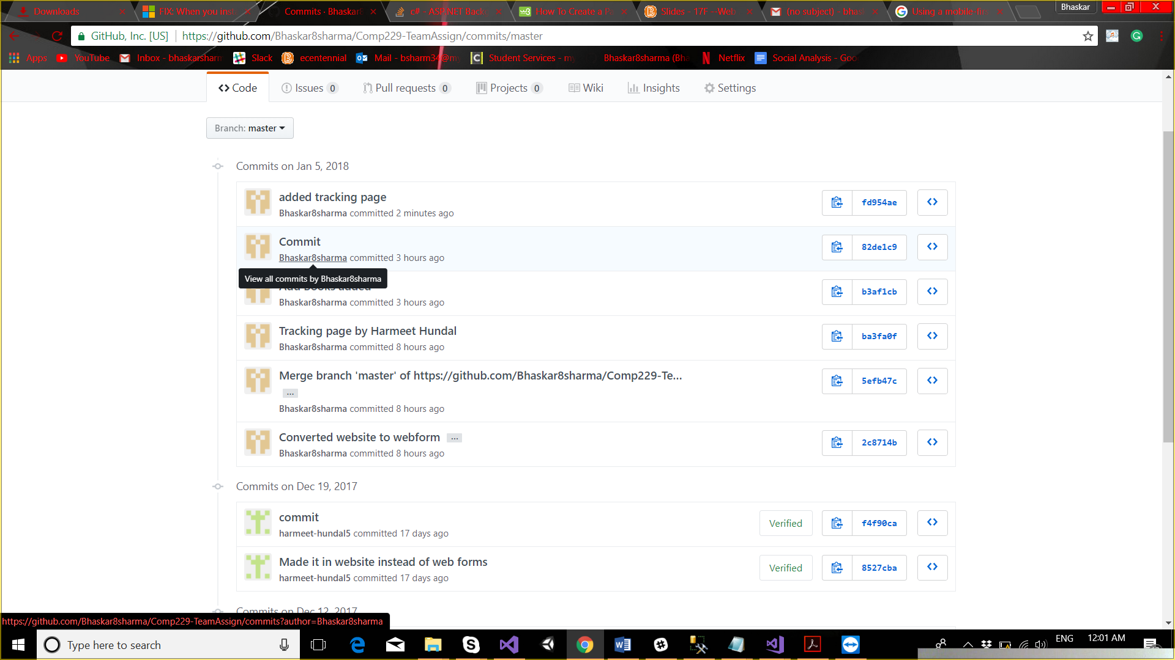

Colour Section

1.Background color - #337AB7

2.White - #FFF

3.Table border and header color 2976B4

Wireframes

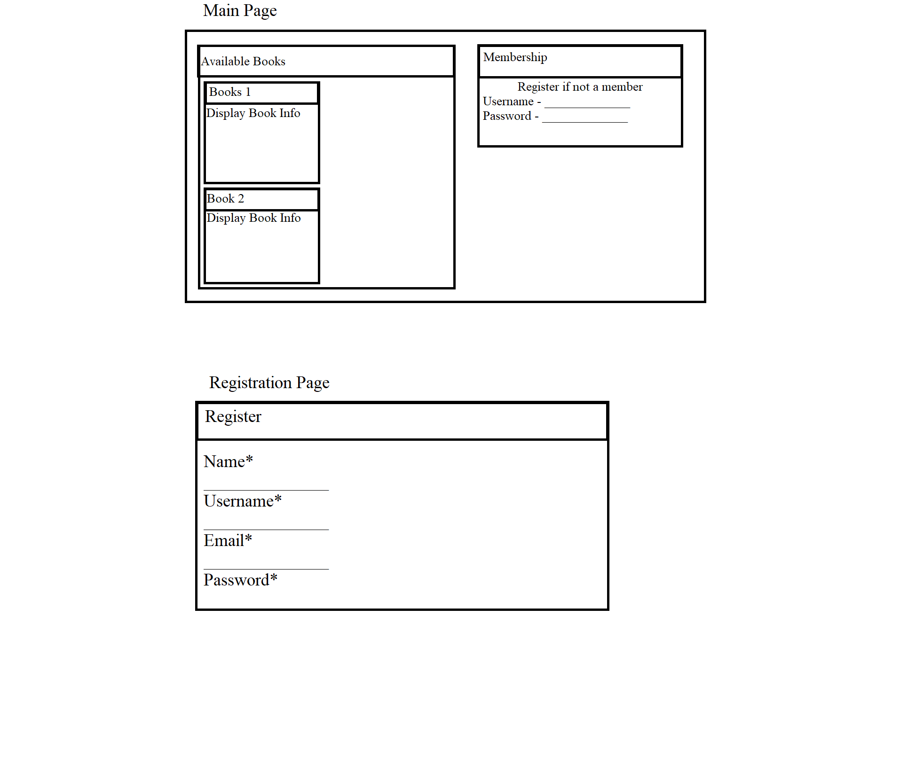

Screen Capture

**Main Page:-**

**A screenshot of a social media post

Description generated with very high confidence**

**Home Page**

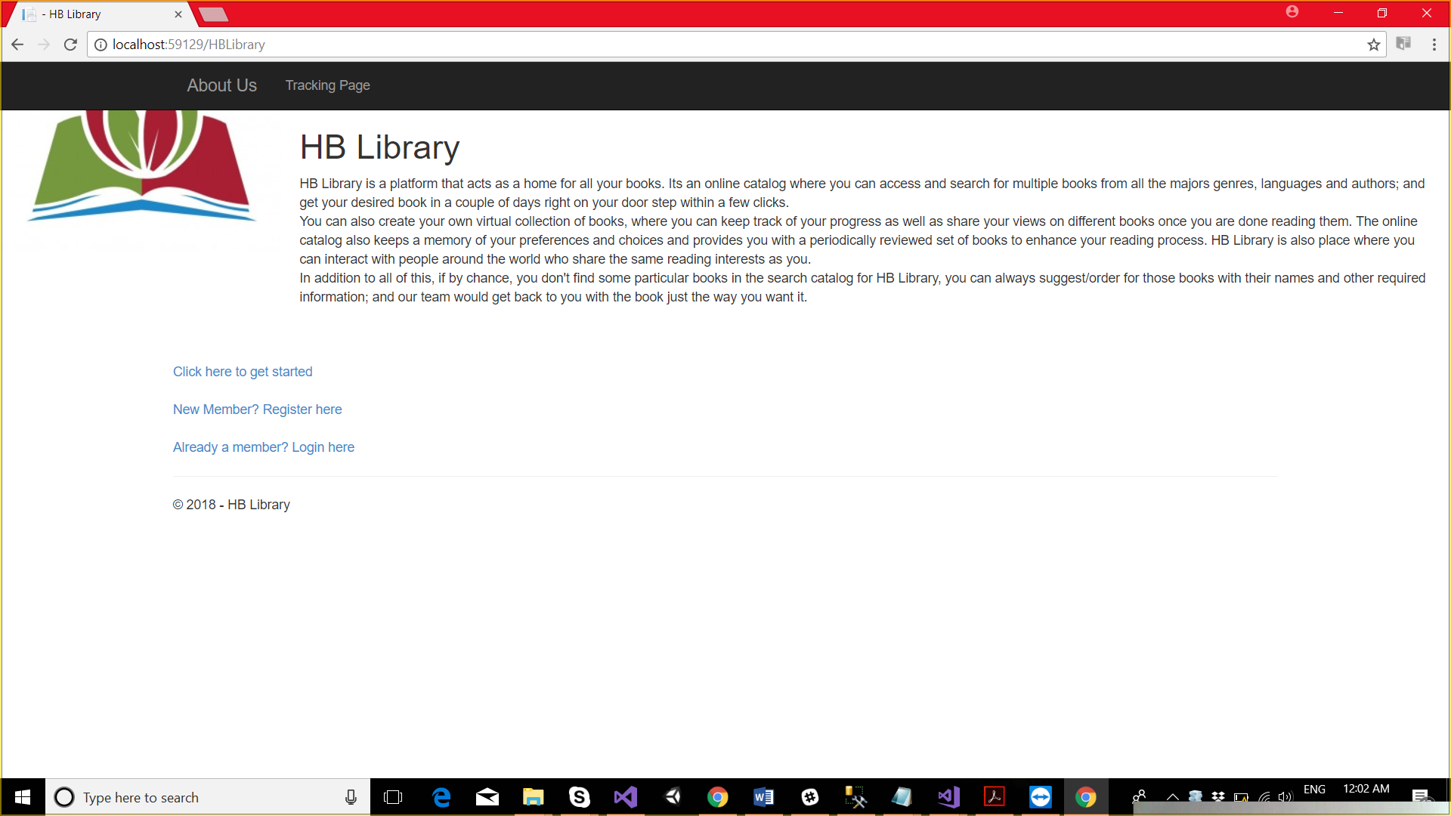

Registration Page:-

**A screenshot of a social media post

Description generated with very high confidence**

**Tracking Page**

